South Australia
Liens on Fruit Act 1923
An Act to provide for preferable liens on fruit, and for other purposes.

Contents
1 Short title
2 Interpretation
3 Right of lienee to fruit crops
4 Lienee protected against sales etc of orchard
5 Payments of rent and Crown instalments by lienee
6 Liens by mortgagors
6A Provision as to payment of water rates
7 Transfer of liens
8 Registration and fees
10 Affidavits, before whom sworn
11 Certain provisions of Act to cease to have effect
12 Provision of information to Commonwealth
13 Immunity
14 Registrar-General may refuse to exercise functions
15 Regulations
16 Repeal of Act
Schedule
Legislative history

The Parliament of South Australia enacts as follows:
1—Short title
This Act may be cited as the Liens on Fruit Act 1923.
2—Interpretation
In the construction of this Act and of all agreements hereunder unless some other meaning is clearly intended—
business day means any day except a Saturday or a Sunday or other public holiday;
fruit crop means a crop growing, or not harvested, of fruit of any kind;
orchard means any land used wholly or in part for the purpose of growing any fruit crop, or means when thereto limited any part of such land specifically described in the agreement hereinafter mentioned;
landlord includes the Crown;
PPS Act means the Personal Property Securities Act 2009 of the Commonwealth;
produce includes all fruit and other result of the harvesting of a fruit crop;
registration commencement time has the same meaning as in the PPS Act;
rent includes licence fees under the Crown Lands Act 1929 or any Act incorporated therewith;
to harvest (in whatever mood, tense, or voice the word is used) includes picking, gathering, bagging, and doing all other things necessary to bring a fruit crop into a marketable condition, and harvest means a crop so harvested.
3—Right of lienee to fruit crops
(1) Subject to subsection (2), in all cases where any person bona fide makes any advance of money or gives any negotiable security, or supplies any chattels to any proprietor of a fruit crop on condition of receiving the produce of the then next ensuing harvest of such proprietor as absolutely purchased by or in payment of or to secure the payment of any such money or negotiable security, or for any such chattels (as the case may be), and where the agreement relating thereto is made in the form of the Schedule hereto, or in a form to the like effect, and is registered within ten days after the date of such agreement by leaving in the office of the Registrar-General of Deeds a true copy thereof, verified on oath before any person authorised to take affidavits, the person making such purchase or advance or giving such negotiable security, or supplying such chattels, shall be entitled to the whole of the fruit crop mentioned in such agreement, whether such advance of money or the giving such negotiable security, or the supply of such chattels, be before, at, or after the granting of any such preferable lien, so long as the registered agreement relating thereto has been made in payment or to secure the payment of such money or negotiable security, or for such chattels; and possession of such fruit crop by the said proprietor, his executors or administrators, shall be to all intents and purposes in the law the possession of the person making such purchase or advancing such money, or giving such negotiable security, or supplying such chattels; and after such advance has been repaid, or such negotiable security satisfied, or such chattels paid for, with such interest and commission as may be specified in any such agreement, the possession and property of the said fruit crop shall, if such agreement was made by way of security, re-vest in such proprietor, subject, nevertheless, to any charge in the meantime created by the proprietor and which then affects the same.
(2) An agreement is not to be registered under this Act following the last business day before the registration commencement time.
4—Lienee protected against sales etc of orchard
After such agreement as aforesaid has been registered as aforesaid, the preferable lien of the lienee on the fruit crop of the then next ensuing harvest of such proprietor shall not be in anywise extinguished, suspended, impaired, or otherwise prejudicially affected by any subsequent sale, mortgage, or other encumbrance whatsoever of the orchard on which such fruit crop then is growing or not harvested, and which is mentioned and described in the registered agreement relating to any such preferable lien, nor by the subsequent insolvency of the lienor, his executors or administrators, nor by any execution against his or their property, but shall be as valid and effectual to all intents and purposes whatsoever against any such subsequent purchaser, mortgagee, encumbrancer, lessee, or other claimant or possessor of the said land, and against the assignees of such insolvent lienor, his executors or administrators, and against any execution creditor, as against the original proprietor thereof who granted such lien. And if any such lienor, subsequent purchaser, mortgagee, encumbrancer, lessee, or other claimant or possessor, assignee, or execution creditor neglects or refuses to harvest at the usual season and deliver forthwith thereafter the fruit crop for which any such preferable lien has been granted as aforesaid, in pursuance of the provisions in that behalf contained in such registered agreement, it shall be lawful for the lienee, his executors or administrators to take possession of the orchard bearing such fruit crop for the purpose of harvesting such fruit crop, and (if authorised by such registered agreement in that behalf) to sell the same; and all expenses attending such harvesting and the conveyance of the produce thereof to the place of abode or business of such lienee, or to the nearest place of shipment, and of any sale as aforesaid, shall be incorporated with and be deemed in law part of the amount secured by such lien.
5—Payments of rent and Crown instalments by lienee
(1) If the leanor is a tenant then the lienee shall before carrying away such fruit crop pay to the landlord of the orchard whereon such fruit crop has been or is growing or not harvested such sum of money not exceeding one year's rent as is due to him for rent at the time of carrying away such fruit crop, and the lienee may repay himself the sum so paid out of the proceeds of the sale of such fruit crop before paying over the balance to the lienor.
(2) If the lienor holds the orchard whereon such fruit crop has been or is growing or not harvested under an agreement for sale and purchase from the Crown, the lienee shall, before carrying away such fruit crop, pay to the person to whom instalments under the agreement are payable such sum of money not exceeding one year's instalments as is due under the agreement at the time of carrying away such fruit crop, and the lienee may repay himself the sum so paid out of the proceeds of the sale of such fruit crop before paying over the balance to the lienor.
6—Liens by mortgagors
If at the time of the granting of such lien there is in force a mortgage of the orchard whereon such fruit crop is growing or not harvested such lienee shall before carrying away such fruit crop pay to the mortgagee the amount of interest not, however, exceeding twelve months' interest due upon such mortgage at the time of carrying away such fruit crop, and such lienee may repay himself the sum so paid for interest out of the proceeds of the sale of such fruit crop before paying over the balance to the lienor.
6A—Provision as to payment of water rates
(1) If at the time of carrying away such fruit crop any money is due and payable by the lienor to any Minister of the Crown, Irrigation Trust, or other public authority for water rates in respect of the orchard whereon such fruit crop has been or is growing or not harvested, or for the price of water supplied by measure to such orchard the lienee shall before carrying away such fruit crop pay to the said Minister, Trust, or other public authority the money so due and payable by the lienor, and the lienee may repay himself the sum so paid out of the proceeds of the sale of such fruit crop before paying over the balance to the lienor: Provided that the lienee shall not be required to pay under this section any water rates in excess of the amount due and payable by the lienor in respect of the last period of twelve months, or the last two periods of six months for which water rates were declared before the carrying away of the fruit crop, nor any sum of water supplied by measure in excess of the amount due and payable by the lienor for water so supplied during the period of twelve months immediately before the said carrying away.
(2) The provision enacted by this section shall apply only where the lien is granted after the commencement of the Liens on Fruit Act 1932.
7—Transfer of liens
Every such registered lien of fruit crop shall be assignable at law by writing; and the assignee thereof respectively may bring every such action thereupon or in respect thereof in his own name, and shall have and may exercise the same right, title, and interest, powers, and authorities as the original lienee could have brought, would have had, or might have exercised if no assignment has been made by him.
8—Registration and fees
(1) The Registrar-General of Deeds shall keep a separate and distinct register from year to year of all such agreements as are referred to in this Act, and shall be entitled to demand for every registration thereof such fee as may for the time being be prescribed therefor; and all persons shall have access to the said registers and may search the same during the usual hours of business on paying such fee as may for the time being be prescribed for every search for each agreement for a purchase of fruit crop or advance thereon. At the end of twelve months next after the expiration of the year for which any such preferable lien upon fruit crop has been given as aforesaid, the Registrar-General of Deeds shall remove from the records of his office such preferable lien, and shall destroy or cancel the same, or at any time at the request of both parties to any such preferable lien, and upon payment of such fee as may for the time being be prescribed shall enter satisfaction on the same.
(2) The Governor may by regulation prescribe fees for the purposes of this section which shall be payable in accordance with the regulations.
(3) Until regulations providing otherwise have been made and have taken effect, the fees prescribed by this section as in force immediately before this subsection comes into operation shall continue to be the fees respectively prescribed for the purposes of this section.
10—Affidavits, before whom sworn
Any affidavit referred to in this Act may be taken or made within the State before any commissioner for taking affidavits in the Supreme Court or before any justice of the peace for the State, and outside the State in the manner provided by the Evidence Act 1929.
11—Certain provisions of Act to cease to have effect
Sections 3 to 7 (inclusive) will cease to have effect at the registration commencement time.
12—Provision of information to Commonwealth
(1) The Registrar-General of Deeds may provide the PPS Registrar, or any other officer of the Commonwealth, with such information concerning agreements registered under this Act, and any other information recorded by the Registrar-General in connection with registration under this Act, as the Registrar-General considers appropriate in order to assist the Commonwealth in establishing the PPS Register.
(2) The Registrar-General of Deeds may provide the information referred to in subsection (1) in such form (including by means of electronic data or in a form approved for the purposes of the PPS Act) as the Registrar-General considers appropriate.
(3) In this section—
PPS Register means the Personal Property Securities Register established under the PPS Act;
PPS Registrar means the Registrar of Personal Property Securities under the PPS Act.
13—Immunity
The State, or an officer, employee or agent of the State, does not incur liability for anything done or omitted to be done in good faith by the State, officer, employee or agent—
(a) in the exercise of a power or the discharge of a duty under section 12; or
(b) in the reasonable belief that the act or omission was in the exercise of a power or the discharge of a duty under section 12.
14—Registrar-General may refuse to exercise functions
(1) The Registrar-General of Deeds may refuse to exercise a function under this Act during the pre-PPS transitional period.
(2) Without limiting subsection (1), the Registrar-General of Deeds may refuse to exercise a function during the pre-PPS transitional period in relation to a matter that was not finally determined or concluded immediately before the commencement of that period.
(3) In this section—
migration time has the same meaning as in the PPS Act;
pre-PPS transitional period means the period—
(a) commencing at the migration time or such earlier time as may be prescribed by the regulations; and
(b) ending at the registration commencement time.
15—Regulations
The Governor may make regulations containing provisions of a savings or transitional nature—
(a) consequent on the enactment of the Personal Property Securities (Commonwealth Powers) Act 2009 or on the commencement of specified provisions of that Act; or
(b) relevant to the interaction between this Act and the PPS Act.
16—Repeal of Act
(1) After the registration commencement time, the Governor may, by proclamation, fix a date for the repeal of this Act.
(2) On the date fixed under subsection (1), this Act is repealed.

Schedule
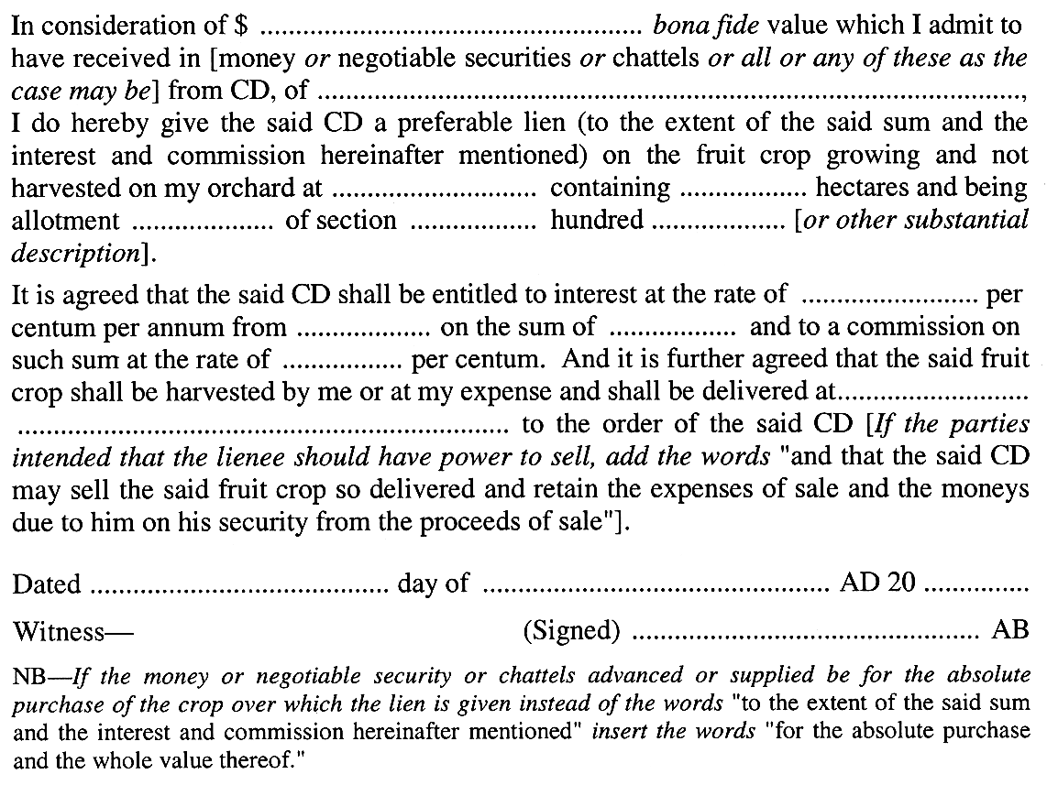

Legislative history
Notes
• Please note—References in the legislation to other legislation or instruments or to titles of bodies or offices are not automatically updated as part of the program for the revision and publication of legislation and therefore may be obsolete.
• Earlier versions of this Act (historical versions) are listed at the end of the legislative history.
• For further information relating to the Act and subordinate legislation made under the Act see the Index of South Australian Statutes or www.legislation.sa.gov.au.
Repeal of Act
The Liens on Fruit Act 1923 will be repealed by proclamation.
After the registration commencement time, the Governor may, by proclamation, fix a date for the repeal of this Act: s 16.
Principal Act and amendments
New entries appear in bold.
Year | No | Title | Assent | Commencement
1923 | 1597 | Liens on Fruit Act 1923 | 6.12.1923 | 6.12.1923
1932 | 2071 | Liens on Fruit Act 1932 | 27.10.1932 | 27.10.1932
1975 | 32 | Statutes Amendment (Miscellaneous Metric Conversions) Act 1975 | 3.4.1975 | 15.1.1976 (Gazette 15.1.1976 p174)
1975 | 118 | Statute Law Revision Act (No. 2) 1975 | 4.12.1975 | 4.12.1975
1994 | 59 | Criminal Law Consolidation (Felonies and Misdemeanours) Amendment Act 1994 | 27.10.1994 | 1.1.1995 (Gazette 8.12.1994 p1942)
2011 | 11 | Statutes Amendment (Personal Property Securities) Act 2011 | 14.4.2011 | Pt 14 (ss 42, 43 & 45)—16.6.2011 (Gazette 16.6.2011 p2610); s 44—30.1.2012 (Gazette 15.12.2011 p4988)
Provisions amended since 3 February 1976
• Legislative history prior to 3 February 1976 appears in marginal notes and footnotes included in the consolidation of this Act contained in Volume 6 of The Public General Acts of South Australia 1837-1975 at page 3.
New entries appear in bold.
Provision | How varied | Commencement
s 2
business day | inserted by 11/2011 s 42(1) | 16.6.2011
PPS Act | inserted by 11/2011 s 42(2) | 16.6.2011
registration commencement time | inserted by 11/2011 s 42(3) | 16.6.2011
s 3
s 3(1) | s 3 amended and redesignated as s 3(1) by 11/2011 s 43(1), (2) | 16.6.2011
s 3(2) | inserted by 11/2011 s 43(2) | 16.6.2011
s 9 | amended by 59/1994 Sch 2 | 1.1.1995
 | deleted by 11/2011 s 44 | 30.1.2012
ss 11—16 | inserted by 11/2011 s 45 | 16.6.2011
Historical versions
Reprint No 1—1.1.1995
16.6.2011

